Introduction to O’Melveny & Myers Beijing Legal Scholarship Awards Program

O’Melveny & Myers LLP is a values-driven law firm guided by the principles of uncompromising excellence, distinctive leadership, and superior citizenship. Established in 1885, the firm maintains 15 offices around the world, with approximately 700 lawyers, and has grown to become one of the largest and most reputable international law firms in the world. O’Melveny & Myers opened its Shanghai office in 1996 and started to provide legal services for China’s fast developing economy, and has become one of the biggest international law firms in Shanghai. Pursuant to Chinese government regulations, O’Melveny & Myers established its Beijing office in 2002, making it one of the first international law firms approved by the Ministry of Justice to practice in both Beijing and Shanghai concurrently. The firm’s Hong Kong office also has a group of outstanding international commercial lawyers, engaging extensively with a range of China-related legal matters.
The firm started the O’Melveny & Myers Beijing Legal Scholarship Awards Program in 2004, with the aim of encouraging and supporting Chinese law students in their study and research, providing assistance in the development and training of legal talents in China, and contributing to legal exchanges and cooperation between China and the United States.
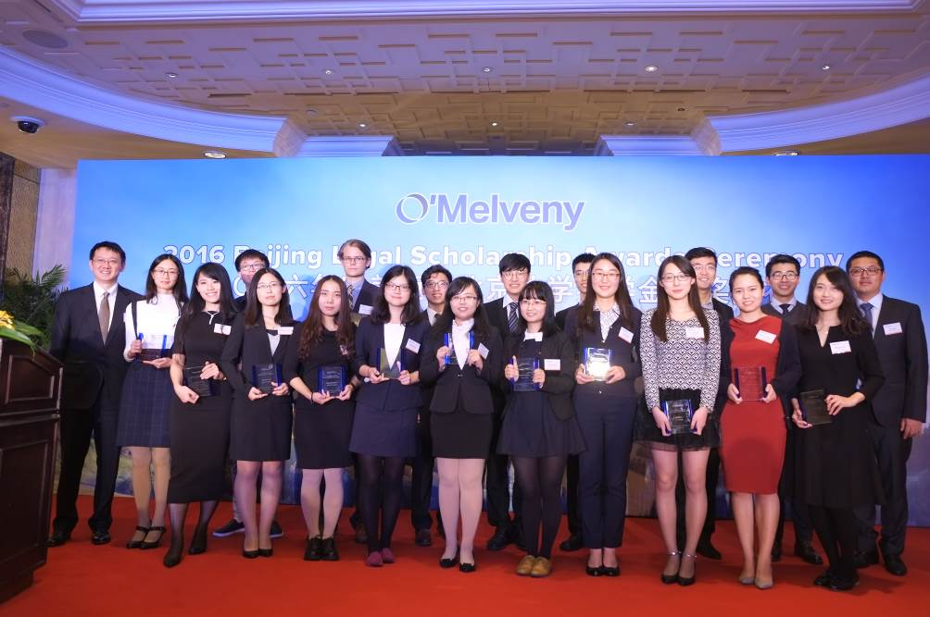

In October 2016, the Thirteenth O’Melveny & Myers Beijing Legal Scholarship Awards Ceremony was held at
Beijing China World Hotel.
In Beijing, a Selection Committee consisting of distinguished professors of law, legal professionals, and representatives from O’Melveny & Myers every year selects a total of 12 award winners from third-year undergraduates majoring in law and second-year postgraduate law students (including doctorate students) from China University of Political Science and Law; the School of Law of the University of International Business and Economics; Peking University Law School; Renmin University of China Law School; and Tsinghua University Law School (in alphabetical order).
The selection process is divided into three phases: nomination by the schools, review of nominees’ materials by the Selection Committee, and interviews with the finalists. First, each of the schools recommends four third-year undergraduates and three second-year postgraduate students from its qualified registered full-time students majoring in law. All recommendations are based on the following criteria: work ethics, good academic performance, strong citizenship and public moral consciousness, passion for public interest work, a good command of English (at least at College English Test Level VI) or another foreign language at a proficiency level equivalent to College English Test Level VI and outstanding performance in other aspects (such as academic research, leadership and social activities). The schools prepare a list of materials for each candidate for submission to the Selection Committee. The materials submitted by each candidate should include a resume in both Chinese and English (each version not exceeding one page), school transcripts with rankings, comments by supervisors on the character of the candidate, and references from two professors. If the candidate has published in the past, the materials should include evaluations on such publication by a professor.
The Selection Committee subsequently conducts a preliminary review of the materials submitted by the schools and selects four students from the seven recommended by each school, two undergraduates and two postgraduates. 20 out of 35 selected candidates will advance to the panel interview.
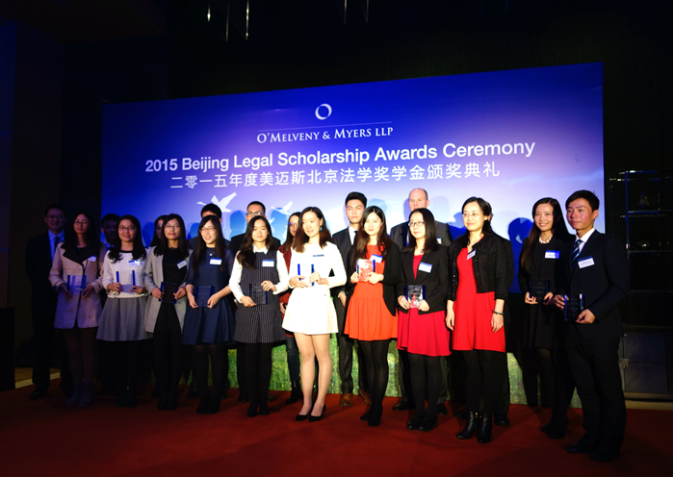
In October 2015, the Twelfth O’Melveny & Myers Beijing Legal Scholarship Awards Ceremony was held at
the Park Hyatt Beijing

O’Melveny & Myers sends notice to the 20 finalists and the Selection Committee arranges panel interviews with each. The interviews are conducted in Chinese or English. Twelve scholarship winners are selected on the basis of an evaluation by the Selection Committee after the interviews. Among the final twelve winners, two are selected for the First Prize Award and ten (five undergraduates and five postgraduates) for the Second Prize Award. Each of the First Prize Award winners receives a scholarship of RMB15,000 and each of the Second Prize Award winners receives a scholarship of RMB7,000.
O’Melveny & Myers will stay in touch with scholarship winners and follow up with their studies and work going forward.
Articles of Establishment of O’Melveny & Myers
Beijing Legal Scholarship
I. Goals
O’Melveny & Myers LLP is a values-driven international law firm guided by the principles of uncompromising excellence, distinctive leadership, and superior citizenship. O’Melveny & Myers LLP has established and funded the O’Melveny & Myers Beijing Legal Scholarship (the “Scholarship”) to encourage and support Chinese law students in their study and research; to provide assistance in the development and training of legal talents in China; and to contribute to legal exchange and cooperation between China and the US.

II. Recipients
Recipients should be third-year full-time undergraduates majoring in law or second-year full-time postgraduate law students (including doctorate students), at China University of Political Science and Law; the School of Law of the University of International Business and Economics; Peking University Law School; Renmin University of China Law School; and Tsinghua University Law School (in alphabetical order).

III. Method of Scholarship Awards
Number of Scholarships: Twelve, of which two are First Prize Award winners and ten (five undergraduates and five postgraduates) are Second Prize Award winners.
Scholarship Amount: First Prize Award winners receive a scholarship of RMB15,000 each, and Second Prize Award winners receive a scholarship of RMB7,000 each.

IV. Qualifications for the Scholarships
1. Work ethics and good academic performance, top 30% in academic record (preferred);
2. Strong citizenship and public moral consciousness, passion for public interest work;
3. Good command of English (at least at College English Test Level VI) or another foreign language at a proficiency level equivalent to College English Test Level VI (applicable to students whose second language is not English);
4. Outstanding performance in other aspects, such as academic research, leadership and social activities.

V. Method of Selection
1. The candidates must be qualified registered full-time students majoring in law at China University of Political Science and Law; the School of Law of the University of International Business and Economics; Peking University Law School; Renmin University of China Law School; and Tsinghua University Law School (in alphabetical order).
2. Each of the above schools may recommend four undergraduates and three postgraduate students eligible for review by the Selection Committee.
3. The above schools should prepare a list of candidates and materials for each candidate for submission to the Selection Committee. The materials for each candidate should include a resume in both Chinese and English (each version not exceeding one page), school transcripts with rankings, comments by supervisors on the character of the candidate, and references from two professors. If the candidate has published in the past, the materials should include evaluations on such publication by a professor. (Detailed requirements on materials may be interpreted and adjusted by the managing unit of each of the participating schools. This Clause shall prevail if no other interpretations are available).
4. The Selection Committee will conduct a preliminary review of the materials submitted by the schools and select four candidates (two undergraduates and two postgraduate students) from the seven candidates recommended by each school, i.e. in all, 20 students out of the 35 candidates.
5. Interviews shall be presided over by members of the Selection Committee. Interviews shall be conducted in Chinese or English. Questions for undergraduates and postgraduates shall be different. Twelve scholarship winners will be selected on the basis of an evaluation after the interviews.
6. Out of the twelve winners, two should be designated as First Prize Award winners, and ten (five undergraduates and five postgraduates) Second Prize Award winners.
7. To ensure a fair and impartial selection process, professors of the Selection Committee shall not grade candidates (in both preliminary review and panel interview) from the university they represent. Each and every finalist before taking the panel interview shall sign a Confidentiality Agreement and undertake not to disclose any interview questions to any third party. O’Melveny & Myers shall reserve the right to forfeit prize award for any breach of the Confidentiality Agreement.

VI. Make-up of the Selection Committee
The Selection Committee consists of distinguished professors of law and representatives from O’Melveny & Myers.

VII. Details of the scholarships will be decided by the Managing Committee of O’Melveny & Myers LLP.

VIII. The Selection Committee has the power of interpreting these Articles.

2017 O’Melveny & Myers Beijing Legal Scholarship Selection Committee
(In Alphabetical Order)

Mr. Ke Geng Partner, O’Melveny & Myers LLP Beijing office

Ms. Bingna Guo Partner, O’Melveny & Myers LLP Beijing office

Prof. Dayuan Han Dean, Law School
Renmin University of China

Prof. Qingjiang Kong Dean, School of International Law
China University of Political Science and Law

Prof. Weixing Shen Dean, Law School
Tsinghua University

Prof. Jingxia Shi Dean, Law School
University of International Business and Economics

Mr. Larry Sussman Managing Partner, O’Melveny & Myers LLP Beijing Office

Prof. Shouwen Zhang Dean, Law School
Peking University

CONTACT INFORMATION OF O’MELVENY & MYERS BEIJING OFFICE
O’Melveny & Myers LLP
37th Floor, Yin Tai Centre, Office Tower
No. 2 Jianguomenwai Avenue
Beijing 100022
Tel: (86)-10-6563-4200
Fax: (86)-10-6563-4201
Working Group Email: ommbjsc@omm.com
www.omm.com www.omm.cn

